Core Concepts and Highlights
- Node Affinity is a scheduling feature that allows pods to be assigned to nodes based on node labels using complex matching expressions and operators.
- It complements Taints and Tolerations, which allow nodes to repel or accept pods but lack fine-grained control over scheduling with multiple conditions.
- Node Affinity uses labels and selectors to schedule pods only on nodes matching specific criteria, enabling better workload segregation (e.g., disk type SSD vs HDD).

Key Differences Between Node Affinity and Taints & Tolerations
Feature | Taints & Tolerations | Node Affinity
Purpose | Allow/restrict pods on nodes via taints and tolerations | Schedule pods on nodes matching label selectors
Expressiveness | Limited: cannot combine multiple conditions | Supports complex expressions, multiple conditions, and operators (In, NotIn, Exists, etc.)
Scheduling Guarantee | Does not guarantee pod scheduling on a specific node | Guarantees pod scheduling on nodes that match affinity rules (with requiredDuringSchedulingIgnoredDuringExecution)
Pod eviction on label change | Pods can be evicted if taints/tolerations no longer match | Pods continue running despite node label changes (ignoredDuringExecution)
Use case | Node-level acceptance or rejection of pods | Fine-grained control over which nodes pods land on

Node Affinity Properties Explained
- requiredDuringSchedulingIgnoredDuringExecution
  - Pods must be scheduled on nodes that match the affinity rules.
  - If no matching node exists, pods remain pending.
  - After scheduling, changes to node labels do not evict the pod.
- preferredDuringSchedulingIgnoredDuringExecution
  - Scheduler prefers nodes that match affinity but will still schedule pods on non-matching nodes if no suitable match is found.
  - Guarantees scheduling but with affinity preference.
  - Also ignores node label changes after the pod is running.

Operators in Node Affinity
- Common operators include:
  - In / NotIn - match values in a list or exclude values
  - Exists - checks for the presence of a label key regardless of its value
  - Other operators are available (check Kubernetes docs)

Practical Demo Overview
- Setup involved labeling nodes with disk types (disk=HDD or disk=SSD).
- Pods were defined with node affinity rules specifying which disk types they should run on.
- When using requiredDuringScheduling..., pods stayed pending if no matching node label existed.
- Switching to preferredDuringScheduling... allowed pods to schedule even without matching labels.
- Demonstrated handling of label changes on nodes after pod scheduling — pods were unaffected.
- Showed how to apply node affinity YAML under spec.affinity.nodeAffinity with proper indentation and syntax.
- Illustrated that node affinity alone does not replace taints and tolerations but works best in combination.

Combining Node Affinity with Taints and Tolerations
- Taints and tolerations control whether a pod can be scheduled on a node by repelling pods that lack matching tolerations.
- Node affinity controls which nodes pods prefer or require based on labels.
- Combining both ensures pods are strictly scheduled on intended nodes which have the right taints and labels.
- Example scenario:
  - Node with taint color=green and label GPU=true.
  - Pod with toleration for taint color=green and node affinity for label GPU=true.
  - Pod schedules only on that node, avoiding others.

Summary Table: Node Affinity Scheduling Behavior
Property | Scheduling Behavior | Pod Status if No Match
requiredDuringSchedulingIgnoredDuringExecution | Pod schedules only on matching nodes | Pod remains Pending
preferredDuringSchedulingIgnoredDuringExecution | Pod prefers matching nodes but will schedule anywhere if none | Pod gets scheduled anyway

Important Notes
- After pods are scheduled, node label changes do not evict running pods, regardless of affinity or tolerations.
- Use requiredDuringScheduling for strict scheduling needs.
- Use preferredDuringScheduling when scheduling success is more important than strict node matching.
- Node affinity and taints/tolerations together provide robust pod placement and workload isolation.
In preferredDuringSchedulingIgnoredDuringExecution, each preference rule has a weight between 1 and 100.
- The weights do not need to add up to 100.
- Instead, they act like relative scores.
Here’s what happens:
- The scheduler looks at all Nodes that satisfy the required rules.
- For each Node, it checks how many of the preferred rules the Node matches.
- Each matching rule contributes its weight to that Node’s total score.
- The scheduler then prefers Nodes with the highest total score.

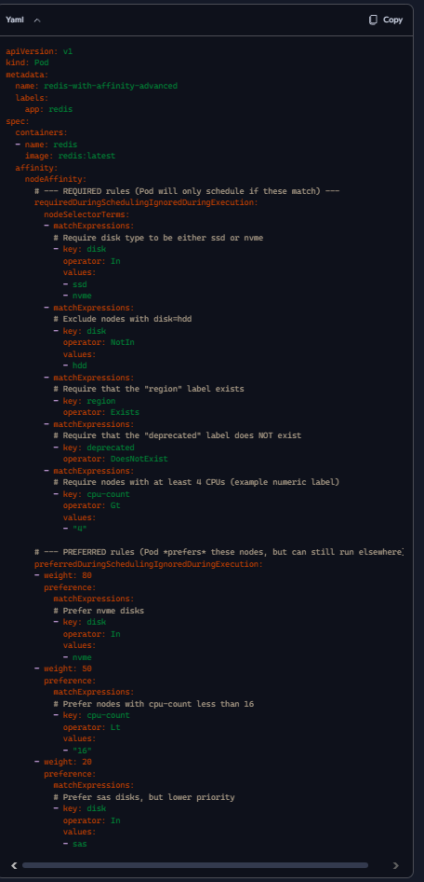

- In → Must match one of the listed values (disk=ssd or disk=nvme).
- NotIn → Must not match listed values (disk≠hdd).
- Exists → Node must have the label key, regardless of value (region).
- DoesNotExist → Node must not have the label key (deprecated).
- Gt / Lt → Numeric comparison on label values (e.g., cpu-count > 4, cpu-count < 16).
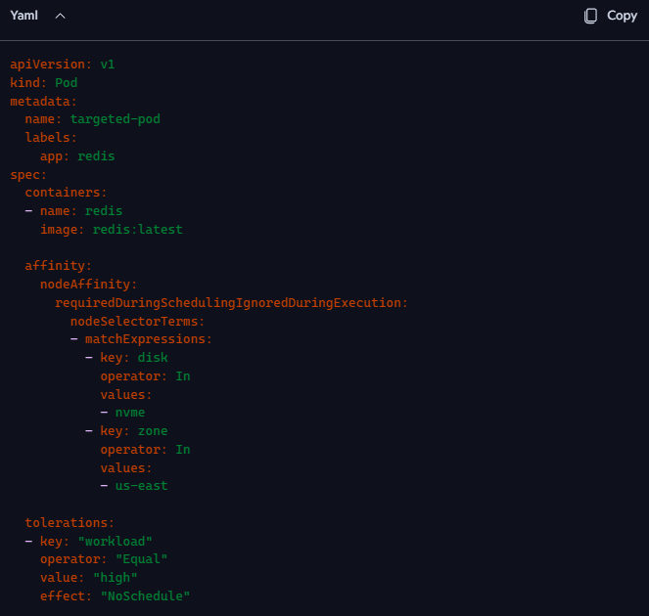

- Affinity: Pod will only be scheduled on nodes with:
- disk=nvme
- zone=us-east
- Toleration: Pod can tolerate the taint workload=high:NoSchedule, which would otherwise block scheduling.

To make this work, your target node must be configured like this:
kubectl label node <node-name> disk=nvme zone=us-east
kubectl taint node <node-name> workload=high:NoSchedule
Other nodes:
- Without these labels → excluded by affinity.
- Without this taint → not matched by toleration, but also excluded by affinity.
So the Pod only runs on nodes that match both label and taint — no fallback.

